Project 2
<Tic Tac Toe>

CIS-18A 86625
Name: James Small
Date: 12/11/10

Introduction

This is a basic game of Tic Tac Toe. You can either play with two human players, alternating turns with X’s and O’s, or play against the computer with three different difficulty levels. Each level of the AI’s intelligence gets better and better and is unbeatable and the hardest setting.

Summary

Project size:
Game.java: 110 lines
TicTacToe.java 682 lines
TicTacToeGame.java 537 lines

The number of variables:
Game.java: 9 Variables
TicTacToe.java 9 Variables
TicTacToeGame.java 37 Variables

The number of methods:
Game.java: 18 Methods
TicTacToe.java 16 Methods
TicTacToeGame.java 7 Methods

The Road to Completion: I started off by taking the idea of making a two player tic tac toe game and expanded it with the ability to play against a computer. I wrote the original version of the program using the console as output in one night. Of course there were bugs, and problems, but the basic concept was worked out.

Instead of tracking each square as either an X or and O, I decided to use numbers. The player 1 was a 5, and the cpu/player 2 was 6. Everytime you picked a square, it put either a 5 or 6 in a multidimensional int array. I found this more useful when trying to calculate where the computer should move, and also if there was winner or not. I was able to check if three squares in a row added up to 5 * 2, or 10. If so, then I knew the third square was blank. If it added up to 16, then I knew it was something like this, XXO. I used that same logic to determine where a block was needed as well. Using this concept, the main program was written.

The next, and most troublesome part, was the computer ai. I didn’t want to have to check every possible outcome, every time the computer needed to make a move. That would have been too much code for sure. After a quick google search for tic tac toe strategy, I ended up at the Wikipedia entry for the game.

http://en.wikipedia.org/wiki/Tic-tac-toe

The basic concept of the tic tac toe strategy is very simple. There are 8 rules to follow. You try and perform rule 1 and if you can’t, you try rule 2, and so on until you get to rule 8, which is a random square. Each of these rules is described below:

Rule 1: This is very simple, if the computer has an opportunity to win, it must win.
Rule 2: If the player is about to win on their next move, block that move.
Rule 3: This is the only rule I didn’t use, as I didn’t have time to figure it out. Basically this rule was to have the computer setup a fork in order to try and win.
Rule 4: This was the tricky one to figure out logically. When playing the game, the goal really is to setup what’s called a fork, which will allow you an opportunity to win in two different directions, and there is nothing the other person can do about it. The computer looks for a fork to be setup, and blocks the square at which a fork would be created with.
Rule 5: Very simple one, if the center is blank, take it.
Rule 6: If the user has one of the corners, take the opposite corner.
Rule 7: Play any empty corner
Rule 8: Play any open square.

Basically while following these rules, you almost force a tie every time, and if the user isn’t paying attention, it produces a win for the computer. Each difficulty level follows some of these rules, but not necessarily all of them:

Easy follows this path, Rule 1, Rule 5, Rule 8
Hard follows this path, Rule 1, Rule 2, Rule 5, Rule 6, Rule 7, Rule 8
Hardest follows this path, Rule 1, Rule 2, Rule 4, Rule 5, Rule 6, Rule 7, Rule 8

There are a couple things I would have liked to change slash add to the project. I would have wanted to implement Rule 3 above, which would have gave the computer and even better chance of winning. I would have also randomly chosen who would go first, the user or the computer. By the time I thought of that, I was so invested in the user going first that it would have been trouble to switch things up. I would have laid the program out better before actually coding. The last thing I would have added is something that I called the trash talker. Basically every time the computer made a move, it message would display on the bottom of the screen related to the type of move and which rule was used. I would have had a bunch of responses and randomly chosen one. It wouldn’t have been that hard to code, just needed more time. Overall I felt that I accomplished what I set to do. The main worry / success came with the ai, which after many many many many games of tic tac toe played, I haven’t been able to beat the computer on the hardest level. We always tie, unless I screw up. This makes me feel like a success as a computer ai in a game sounds difficult in concept, you just have to move through it one step at a time.

FlowChart

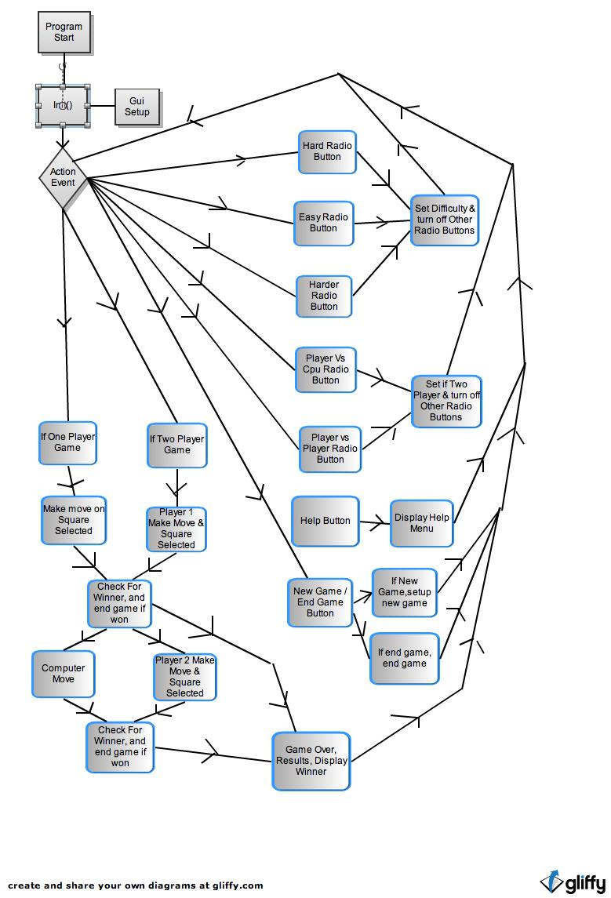

Pseudo Code

Initialize
Gui Setup

If cpu/player or player vs player buttons pressed
Set game as appropriate value

If difficulty level buttons pressed
Set game as appropriate value

If help buttons pressed
Display help menu

If game start button pressed

Pass difficulty level into tictactoe object
Disable all non essential buttons
Enable game buttons

Select square for move and pass value into game variable.

If one player, have cpu move, else have player 2 move,

Update display

Check For Winner

If winner, highlight winning squares
Display outcome message
Increase results on bottom of game board.

Screen Shot Input and Outputs

Before game begins:

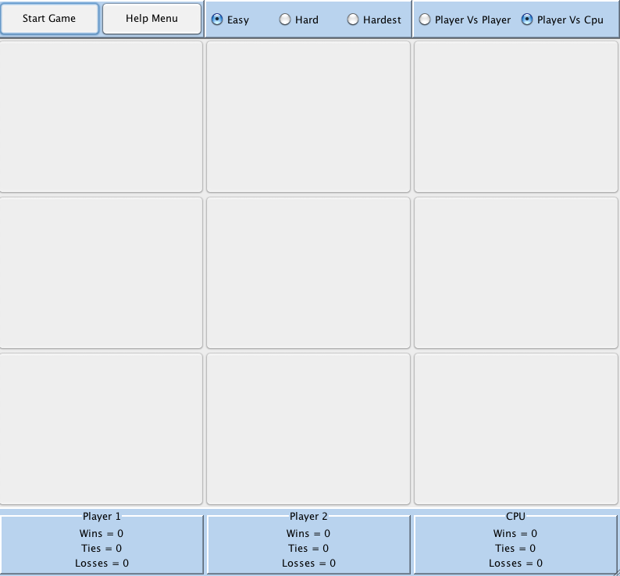

After Game Over:

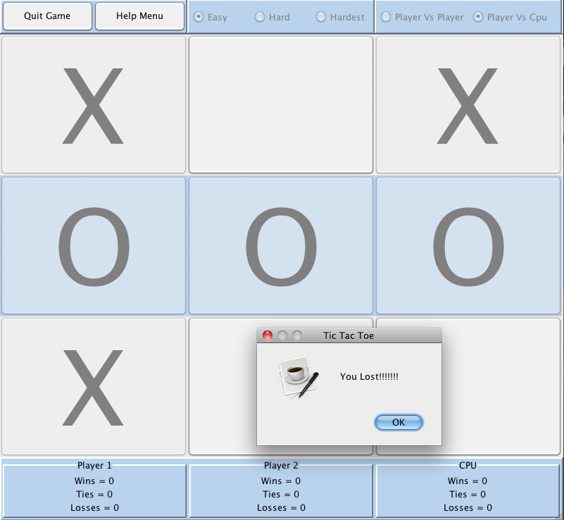

Help Menu
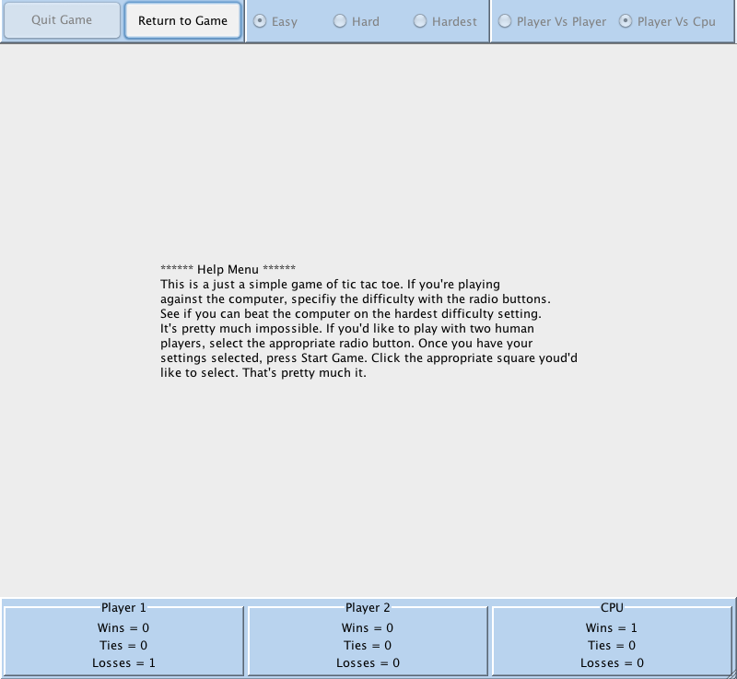

Major Variables

Type | Variable Name | Description | Location
Integer | Player1Wins | Player 1 win count | Game.java
 | Player2Wins | Player 2 win count | Game.java
 | cpuWins | Cpu win count | Game.java
 | Player1Losses | Player 1 losses count | Game.java
 | Player2Losses | Player 2 losses count | Game.java
 | cpuLosses | CPU Losses count | Game.java
 | Player1Ties | Player 1 Ties Count | Game.java
 | Player2Ties | Player 2 Ties Count | Gama.java
 | cpuTies | CPU Ties count | Gama.java
 | User | User value on board | Tictactoe.java
 | Comp | Comp value on board | Tictactoe.java
 | Board[][] | 2 Dimensional Array for board | Tictactoe.java
 | compMove | Location of computer move | Tictactoe.java ;tictactoegame.java
 | Difficulty | Difficulty of computer ai | Tictactoe.java; tictactoegame.java
 | winningLine | Winning Line number for gui | Tictactoe.java
 | Turn | Whos turn it is | Tictactoegame.java
Boolean | aiDone | True if ai made move | Tictactoe.java
 | gameOn | True if game is currently active | Tictactoegame.java
 | helpMenu | True if help menu is displaying | Tictactoegame.java
 | twoPlayert | True if two player game | Tictactoegame.java
Random | Randomizer | Used to randomly guess move | Tictactoe.java
Font | F | Used for font on gui for moves | Tictactoe.java
Container | C | Container for gui | Tictactoegame.java
Jlabel | Top | Top menu on gui | Tictactoegame.java
 | Middle | Used for Gui | Tictactoegame.java
 | Middle2 | Used for Gui | Tictactoegame.java
 | bottom | Used for Gui | Tictactoegame.java
 | Player1wins | Used for Gui | Tictactoegame.java
 | Player2wins | Used for Gui | Tictactoegame.java
 | cpuwins | Used for Gui | Tictactoegame.java
 | Player1losses | Used for Gui | Tictactoegame.java
 | Player2losses | Used for Gui | Tictactoegame.java
 | Cpulosses | Used for Gui | Tictactoegame.java
 | Player1ties | Used for Gui | Tictactoegame.java
 | Player2ties | Used for Gui | Tictactoegame.java
 | cputies | Used for Gui | Tictactoegame.java
JRadioButton | Easy | Used for Gui | Tictactoegame.java
 | Hard | Used for Gui | Tictactoegame.java
 | Harder | Used for Gui | Tictactoegame.java
 | Players | Used for Gui | Tictactoegame.java
 | cpu | Used for Gui | Tictactoegame.java
JButton | Newgame | Used for Gui | Tictactoegame.java
 | Help | Used for Gui | Tictactoegame.java
 | Grid[] | Used for Gui | Tictactoegame.java
JPanel | Left | Used for Gui | Tictactoegame.java
 | Center | Used for Gui | Tictactoegame.java
 | Right | Used for Gui | Tictactoegame.java
 | Bleft | Used for Gui | Tictactoegame.java
Border | Bcenter | Used for Gui | Tictactoegame.java
 | Bright |  | Tictactoegame.java
 | bevel |  | Tictactoegame.java
Java Constructs

Chapter | New syntax and Keywords | Location
2 | public class (class definition) | Public class tictactoe.java
2 | Import declartion | Import java.awt.*  Import java.swing.*  Import java.util.random
2 | Variable declartion statement | Multiple at beginning of program
2 | Assignment Operator | Many times throughout program
2 | If/else selection structure | Used throughout program
4 | Nested if/else statements | Used throughout program
4 | Compound Assignment Operators | Used throughout program
4 | Increment Operator | Used throughout program
4 | Extends | Tictactoe.java extends game.java
4 | Switch | Used throughout program
5 | Logical operators | Used when asking user input to determine if results are within valid range || and &&
5 | Do/while loops | Used on user input, waiting for number in valid range of numbers
5 | JOPtionPane | User for input and output with dialog boxes
5 | JLabel | Used on gui
6 | JButton | Used on gui
7 | Arrays | gui and tictactoe.java class
8 | Constructor | Used in tictactoe.java and game.java
8 | Set and Get Methods | Used throughout program
8 | Final instance variables | Used for user and comp board values
9 | Super classes | Game.java
9 | Subclasses | Tictactoe.java
9 | Protected members | Private variables used throughout
11 | JPanel | Used on gui
11 | ActionEvent | Waits for input
11 | Action Listener | Listens for events in program
11 | GridLayout | Used in Gui to create columns

Reference
- Textbook
- Found border tutorials and examples from http://leepoint.net/notes-java/GUI-appearance/borders/15bordersex.html
- Grid Layout: http://download.oracle.com/javase/1.4.2/docs/api/java/awt/GridLayout.html
- Listener and Action Event from Apply Examples in Lesson 9

Program

//The code doesn’t copy and paste well out of Eclipse into word. The spacing seems to be off so that’s why it looks so funny below.

TicTacToeGame.java

import java.awt.*;
import java.awt.event.*;
import javax.swing.*;
import javax.swing.border.Border;
import javax.swing.border.TitledBorder;

public class TicTacToeGame extends JApplet implements ActionListener {

private static final long serialVersionUID = 10101010;
private JFrame frame;
private JMenuBar top;
private JLabel middle,middle2,bottom,player1Wins,player2Wins,cpuWins,player1Losses,player2Losses,cpuLosses,player1Ties,player2Ties,cpuTies;
private JRadioButton easy,hard,harder,players,cpu;
private JButton newGame,help,grid[];
private JPanel left,center,right,bleft,bcenter,bright;
private Border bevel;

private boolean gameOn = false, helpMenu = false;
private int compMove;
private boolean twoPlayer = false;
private int turn = 1;
private int difficulty = 1;
private Font f = new Font("Dialog", Font.PLAIN, 148);

TicTacToe ttt = new TicTacToe();

public void init()
{
guiSetup(); // Run's method to setup gui
} // end init method

public void actionPerformed( ActionEvent e ) // waits for action performed
{
ttt.display();

if(e.getSource() == hard)
{
easy.setSelected(false);
harder.setSelected(false);
difficulty = 2;
}

if(e.getSource() == easy)
{
hard.setSelected(false);
harder.setSelected(false);
difficulty = 1;
}

if(e.getSource() == harder)
{
easy.setSelected(false);
hard.setSelected(false);
difficulty = 3;
}

if(e.getSource() == players)
{
cpu.setSelected(false);
twoPlayer = true;
}

if(e.getSource() == cpu)
{
players.setSelected(false);
twoPlayer = false;
}

if(e.getSource() == help)
help();

for(int i = 1;i <= 9;i++)
{
if(!twoPlayer)
{
if(e.getSource() == grid[i])
{
grid[i].setEnabled(false);
grid[i].setText("X");
ttt.userInput(i);

if(ttt.checkForWinner() != 0)
{
gameOver(ttt.checkForWinner());
break;
}

if(gameOn)
{
compMove = ttt.aiInput();
grid[compMove].setText("O");
grid[compMove].setEnabled(false);

if(ttt.checkForWinner() != 0)
{
gameOver(ttt.checkForWinner());
break;
}
} // end game on if
} // end button get source
} // end if two player
else
{
if(e.getSource() == grid[i])
{
if(turn == 1 && gameOn)
{

grid[i].setEnabled(false);
grid[i].setText("X");
ttt.userInput(i);

if(ttt.checkForWinner() != 0)
{
gameOver(ttt.checkForWinner());
break;
}

turn = 2;
}
else if(turn == 2 && gameOn)
{
grid[i].setEnabled(false);
grid[i].setText("O");
ttt.userInput2(i);

if(ttt.checkForWinner() != 0)
{
gameOver(ttt.checkForWinner());
break;
}

turn = 1;
}
}

}
} // end for loop for buttons

if(e.getSource() == newGame)
{
if(gameOn)
{
easy.setEnabled(true);
hard.setEnabled(true);
harder.setEnabled(true);
cpu.setEnabled(true);
players.setEnabled(true);
newGame.setText("New Game");
gameOn = false;

for(int i = 1;i <= 9;i++)
{
grid[i].setEnabled(false);
grid[i].setText("");
grid[i].setBackground(Color.white);
}
ttt.initialize();
}
else
{
easy.setEnabled(false);
hard.setEnabled(false);
harder.setEnabled(false);
cpu.setEnabled(false);
players.setEnabled(false);
newGame.setText("Quit Game");
gameOn = true;

for(int i = 1;i <= 9;i++)
{
grid[i].setEnabled(true);
}

ttt.difficulty(difficulty);
}
}
} // end action performed method

public void help()
{
if(helpMenu)
{
helpMenu = false;
middle.setVisible(true);
easy.setEnabled(true);
hard.setEnabled(true);
harder.setEnabled(true);
cpu.setEnabled(true);
players.setEnabled(true);
newGame.setEnabled(true);
help.setText("Help Menu");

}
else
{
helpMenu = true;
middle.setVisible(false);
easy.setEnabled(false);
hard.setEnabled(false);
harder.setEnabled(false);
cpu.setEnabled(false);
players.setEnabled(false);
newGame.setEnabled(false);
help.setText("Return to Game");
frame.getContentPane().add(middle2, BorderLayout.CENTER);

}

}

public void gameOver(int winner)
{
if(twoPlayer)
{
if(winner == 1)
{
System.out.print("You won");
ttt.player1WinsIncrease();
ttt.player2LossesIncrease();
}
else if (winner == 2)
{
System.out.print("You lost");
ttt.player2WinsIncrease();
ttt.player1LossesIncrease();

}
else if (winner == 3)
{
System.out.print("It's a tie");
ttt.player1TiesIncrease();
ttt.player2TiesIncrease();
}
}
else
{
if(winner == 1)
{
System.out.print("You won");
ttt.player1WinsIncrease();
ttt.cpuLossesIncrease();
}
else if (winner == 2)
{
System.out.print("You lost");
ttt.cpuWinsIncrease();
ttt.player1LossesIncrease();
}
else if (winner == 3)
{
System.out.print("It's a tie");
ttt.player1TiesIncrease();
ttt.cpuTiesIncrease();
}
}

highlightWinner();
ttt.setWinningLine(0);
refreshBottomDisplay();

for(int i = 1;i <= 9;i++)
{
grid[i].setEnabled(false);
}
}

public void highlightWinner()
{
switch(ttt.winningLine())
{
case 1:
grid[1].setBackground(new Color(185,211,238));
grid[2].setBackground(new Color(185,211,238));
grid[3].setBackground(new Color(185,211,238));
break;
case 2:
grid[4].setBackground(new Color(185,211,238));
grid[5].setBackground(new Color(185,211,238));
grid[6].setBackground(new Color(185,211,238));
break;
case 3:
grid[7].setBackground(new Color(185,211,238));
grid[8].setBackground(new Color(185,211,238));
grid[9].setBackground(new Color(185,211,238));
break;
case 4:
grid[1].setBackground(new Color(185,211,238));
grid[4].setBackground(new Color(185,211,238));
grid[7].setBackground(new Color(185,211,238));
break;
case 5:
grid[2].setBackground(new Color(185,211,238));
grid[5].setBackground(new Color(185,211,238));
grid[8].setBackground(new Color(185,211,238));
break;
case 6:
grid[3].setBackground(new Color(185,211,238));
grid[6].setBackground(new Color(185,211,238));
grid[9].setBackground(new Color(185,211,238));
break;
case 7:
grid[1].setBackground(new Color(185,211,238));
grid[5].setBackground(new Color(185,211,238));
grid[9].setBackground(new Color(185,211,238));
break;
case 8:
grid[3].setBackground(new Color(185,211,238));
grid[5].setBackground(new Color(185,211,238));
grid[7].setBackground(new Color(185,211,238));
break;
}

}

public void refreshBottomDisplay()
{
player1Wins.setText("Wins = " + ttt.getPlayer1Wins());
player2Wins.setText("Wins = " + ttt.getPlayer2Wins());
cpuWins.setText("Wins = " + ttt.getCpuWins());

player1Losses.setText("Losses = " + ttt.getPlayer1Losses());
player2Losses.setText("Losses = " + ttt.getPlayer2Losses());
cpuLosses.setText("Losses = " + ttt.getCpuLosses());

player1Ties.setText("Ties = " + ttt.getPlayer1Ties());
player2Ties.setText("Ties = " + ttt.getPlayer2Ties());
cpuTies.setText("Ties = " + ttt.getCpuTies());
}

public void guiSetup() // Setup Gui portion of program
{
frame = new JFrame("Tic Tac Toe - Impossible to Beat on the Hardest Level");
frame.setDefaultCloseOperation(JFrame.EXIT_ON_CLOSE);

bevel = BorderFactory.createRaisedBevelBorder();
TitledBorder titlePlayer1 = BorderFactory.createTitledBorder(bevel, "Player 1");
titlePlayer1.setTitleJustification(TitledBorder.CENTER);
TitledBorder titlePlayer2 = BorderFactory.createTitledBorder(bevel, "Player 2");
titlePlayer2.setTitleJustification(TitledBorder.CENTER);
TitledBorder titleCpu = BorderFactory.createTitledBorder(bevel, "CPU");
titleCpu.setTitleJustification(TitledBorder.CENTER);

top = new JMenuBar();
top.setOpaque(true);
top.setBackground(new Color(185,211,238));
top.setPreferredSize(new Dimension(800,50));
top.setLayout(new GridLayout(0,3));

left = new JPanel();
left.setOpaque(true);
left.setBackground(new Color(185,211,238));
left.setPreferredSize(new Dimension(800,50));
left.setBorder(bevel);
left.setLayout(new GridLayout(0,2));

center = new JPanel();
center.setBackground(new Color(185,211,238));
center.setPreferredSize(new Dimension(800,50));
center.setBorder(bevel);
center.setLayout(new GridLayout(0,3));

right = new JPanel();
right.setBackground(new Color(185,211,238));
right.setPreferredSize(new Dimension(800,50));
right.setBorder(bevel);
right.setLayout(new GridLayout(0,2));

top.add(left);
top.add(center);
top.add(right);

easy = new JRadioButton("Easy");
easy.setBackground(new Color(185,211,238));
easy.setSelected(true);
easy.addActionListener(this);

hard = new JRadioButton("Hard");
hard.setBackground(new Color(185,211,238));
hard.addActionListener(this);

harder = new JRadioButton("Hardest");
harder.setBackground(new Color(185,211,238));
harder.addActionListener(this);

players = new JRadioButton("Player Vs Player");
players.setBackground(new Color(185,211,238));
players.addActionListener(this);

cpu = new JRadioButton("Player Vs Cpu");
cpu.setBackground(new Color(185,211,238));
cpu.setSelected(true);
cpu.addActionListener(this);

newGame = new JButton("Start Game");
newGame.addActionListener(this);
help = new JButton("Help Menu");
help.addActionListener(this);

left.add(newGame);
left.add(help);
center.add(easy);
center.add(hard);
center.add(harder);
right.add(players);
right.add(cpu);

middle2 = new JLabel("<html>****** Help Menu ******<br></br>This is a just a simple game of tic tac toe. If you're playing<br></br>" +
"against the computer, specifiy the difficulty with the radio buttons.<br></br>" +
"See if you can beat the computer on the hardest difficulty setting.<br></br>" +
"It's pretty much impossible. If you'd like to play with two human<br></br>" +
"players, select the appropriate radio button. Once you have your<br></br>" +
"settings selected, press Start Game. Click the appropriate square youd'd<br></br>" +
"like to select. That's pretty much it.</html>");
middle2.setBackground(Color.darkGray);
middle2.setPreferredSize(new Dimension(600,600));
middle2.setLayout(new FlowLayout());
middle2.setHorizontalAlignment( SwingConstants.CENTER );
middle2.setVerticalAlignment( SwingConstants.CENTER );

middle = new JLabel();
middle.setBackground(Color.darkGray);
middle.setPreferredSize(new Dimension(600,600));
middle.setLayout(new GridLayout(3,3));

grid = new JButton[10];

for(int i = 1;i <= 9;i++)
{
grid[i] = new JButton();
grid[i].addActionListener(this);
grid[i].setOpaque(true);
grid[i].setFont(f);
grid[i].setEnabled(false);
middle.add(grid[i]);
}

bottom = new JLabel();
bottom.setOpaque(true);
bottom.setBackground(new Color(185,211,238));
bottom.setPreferredSize(new Dimension(800,90));
bottom.setLayout(new GridLayout(0,3));
bottom.setBorder(bevel);

bleft = new JPanel();
bleft.setOpaque(true);
bleft.setBackground(new Color(185,211,238));
bleft.setPreferredSize(new Dimension(800,90));
bleft.setBorder(titlePlayer1);
bleft.setLayout(new GridLayout(3,1));

player1Wins = new JLabel();
player1Wins.setBackground(new Color(185,211,238));
player1Wins.setHorizontalAlignment( SwingConstants.CENTER );

player1Ties = new JLabel();
player1Ties.setBackground(new Color(185,211,238));
player1Ties.setHorizontalAlignment( SwingConstants.CENTER );

player1Losses = new JLabel();
player1Losses.setBackground(new Color(185,211,238));
player1Losses.setHorizontalAlignment( SwingConstants.CENTER );

bleft.add(player1Wins);
bleft.add(player1Ties);
bleft.add(player1Losses);

bottom.add(bleft);

bcenter = new JPanel();
bcenter.setOpaque(true);
bcenter.setBackground(new Color(185,211,238));
bcenter.setPreferredSize(new Dimension(800,90));
bcenter.setBorder(titlePlayer2);
bcenter.setLayout(new GridLayout(3,1));

player2Wins = new JLabel();
player2Wins.setBackground(new Color(185,211,238));
player2Wins.setHorizontalAlignment( SwingConstants.CENTER );

player2Ties = new JLabel();
player2Ties.setBackground(new Color(185,211,238));
player2Ties.setHorizontalAlignment( SwingConstants.CENTER );

player2Losses = new JLabel();
player2Losses.setBackground(new Color(185,211,238));
player2Losses.setHorizontalAlignment( SwingConstants.CENTER );

bcenter.add(player2Wins);
bcenter.add(player2Ties);
bcenter.add(player2Losses);

bottom.add(bcenter);

bright = new JPanel();
bright.setOpaque(true);
bright.setBackground(new Color(185,211,238));
bright.setPreferredSize(new Dimension(800,90));
bright.setBorder(titleCpu);
bright.setLayout(new GridLayout(3,1));

cpuWins = new JLabel();
cpuWins.setBackground(new Color(185,211,238));
cpuWins.setHorizontalAlignment( SwingConstants.CENTER );

cpuTies = new JLabel();
cpuTies.setBackground(new Color(185,211,238));
cpuTies.setHorizontalAlignment( SwingConstants.CENTER );

cpuLosses = new JLabel();
cpuLosses.setBackground(new Color(185,211,238));
cpuLosses.setHorizontalAlignment( SwingConstants.CENTER );

bright.add(cpuWins);
bright.add(cpuTies);
bright.add(cpuLosses);

bottom.add(bright);

frame.setJMenuBar(top);
frame.getContentPane().add(middle, BorderLayout.CENTER);
frame.getContentPane().add(bottom, BorderLayout.SOUTH);

frame.pack();
frame.setVisible(true);

refreshBottomDisplay();

} // end guiSetup method
}

TicTacToe.java

import java.util.Random;

public class TicTacToe extends game
{
private final int user = 5;
private final int comp = 6;
private int board[][];
private int compMove;
private int difficulty = 1;
private int winningLine = 0;
private boolean aiDone = false;
Random randomizer = new Random();

public TicTacToe()
{
board = new int[3][3];
initialize();
}

public void aiWin()
{
for(int row = 0;row < 3;row++)
{
if((board[row][0] + board[row][1] + board[row][2]) == (comp * 2) && aiDone == false)
{
for(int i = 0;i < 3;i++)
{
if(board[row][i] == 0)
{
board[row][i] = comp;
compMove = (row * 3) + i + 1;
}

}
aiDone = true;
System.out.print("\nai Win1\n");
}
}

for(int col = 0;col < 3;col++)
{
if((board[0][col] + board[1][col] + board[2][col]) == (comp * 2) && aiDone == false)
{
for(int i = 0;i < 3;i++)
{
if(board[i][col] == 0)
{
board[i][col] = comp;
compMove = (i * 3) + col + 1;
}
}
aiDone = true;
System.out.print("\nai Win2\n");
}
}

if((board[0][0] + board[1][1] + board[2][2]) == (comp * 2) && aiDone == false)
{

for(int i = 0;i < 3;i++)
{
if(board[i][i] == 0)
{
board[i][i] = comp;
compMove = ((i + i) * 2) + 1;
aiDone = true;
System.out.print("\nai Win3\n");
}
}
}

if((board[0][2] + board[1][1] + board[2][0]) == (comp * 2) && aiDone == false)
{
for(int i = 0;i < 3;i++)
{
if(board[i][2 - i] == 0)
{
board[i][2 - i] = comp;
compMove = (i * 3) + (2 - i) + 1;
aiDone = true;
System.out.printf("\nai Win6 Comp move = %d\n",compMove);
}
}
}
}

public void aiFork()
{

if(board[0][0] == user && board[2][1] == user && board[2][0] == 0 && !aiDone)
{
board[2][0] = comp;
compMove = 7;
aiDone = true;
System.out.print("\nai fork1\n");
}

if(board[0][0] == user && board[1][2] == user && board[0][2] == 0 && !aiDone)
{
board[0][2] = comp;
compMove = 3;
aiDone = true;
System.out.print("\nai fork2\n");
}

if(board[2][0] == user && board[0][1] == user && board[0][0] == 0 && !aiDone)
{
board[0][0] = comp;
compMove = 1;
aiDone = true;
System.out.print("\nai fork3\n");
}

if(board[2][0] == user && board[1][2] == user && board[2][2] == 0 && !aiDone)
{
board[2][2] = comp;
compMove = 9;
aiDone = true;
System.out.print("\nai fork4\n");
}

if(board[0][2] == user && board[1][0] == user && board[0][0] == 0 && !aiDone)
{
board[0][0] = comp;
compMove = 1;
aiDone = true;
System.out.print("\nai fork5\n");
}

if(board[0][2] == user && board[2][1] == user && board[2][2] == 0 && !aiDone)
{
board[2][2] = comp;
compMove = 9;
aiDone = true;
System.out.print("\nai fork6\n");
}

if(board[2][2] == user && board[0][1] == user && board[0][2] == 0 && !aiDone)
{
board[0][2] = comp;
compMove = 3;
aiDone = true;
System.out.print("\nai fork7\n");
}

if(board[2][2] == user && board[1][0] == user && board[2][0] == 0 && !aiDone)
{
board[2][0] = comp;
compMove = 7;
aiDone = true;
System.out.print("\nai fork8\n");
}

}

public void aiBlock()
{
for(int row = 0;row < 3;row++)
{
if((board[row][0] + board[row][1] + board[row][2]) == (user * 2) && aiDone == false)
{
for(int i = 0;i < 3;i++)
{
if(board[row][i] == 0)
{
board[row][i] = comp;
compMove = (row * 3) + i + 1;
}
}
aiDone = true;
System.out.print("\nai block\n");
}
}

for(int col = 0;col < 3;col++)
{
if((board[0][col] + board[1][col] + board[2][col]) == (user * 2) && aiDone == false)
{
for(int i = 0;i < 3;i++)
{
if(board[i][col] == 0)
{
board[i][col] = comp;
compMove = (i * 3) + col + 1;
}
}
aiDone = true;
System.out.print("\nai block\n");
}
}

if((board[0][0] + board[1][1] + board[2][2]) == (user * 2) && aiDone == false)
{
if(board[0][0] == 0)
{
board[0][0] = comp;
compMove = 1;
}

if(board[1][1] == 0)
{
board[1][1] = comp;
compMove = 5;
}

if(board[2][2] == 0)
{
board[2][2] = comp;
compMove = 9;
}

aiDone = true;
System.out.print("\nai block\n");
}

if((board[0][2] + board[1][1] + board[2][0]) == (user * 2) && aiDone == false)
{

if(board[0][2] == 0)
{
board[0][2] = comp;
compMove = 3;
}

if(board[1][1] == 0)
{
board[1][1] = comp;
compMove = 5;
}

if(board[2][0] == 0)
{
board[2][0] = comp;
compMove = 7;
}
aiDone = true;
System.out.print("\nai block\n");
}

}

public void aiCenter()
{
if(board[1][1] == 0 && aiDone == false)
{
board[1][1] = comp;
compMove = 5;
aiDone = true;
System.out.print("\nai center\n");
}
}

public void aiOpposite()
{
if(board[0][0] == user && aiDone == false)
{
if(board[0][1] == 0 && aiDone == false)
{
board[0][1] = comp;
compMove = 2;
aiDone = true;
System.out.print("\nai opposite1\n");
}

if(board[1][0] == 0 && aiDone == false)
{
board[1][0] = comp;
compMove = 4;
aiDone = true;
System.out.print("\nai opposite1\n");
}

}

if(board[0][2] == user && aiDone == false)
{
if(board[0][1] == 0 && aiDone == false)
{
board[0][1] = comp;
compMove = 2;
aiDone = true;
System.out.print("\nai opposite2\n");
}
if(board[1][2] == 0 && aiDone == false)
{
board[1][2] = comp;
compMove = 6;
aiDone = true;
System.out.print("\nai opposite2\n");
}

}

if(board[2][0] == user && aiDone == false)
{
if(board[1][0] == 0 && aiDone == false)
{
board[1][0] = comp;
compMove = 4;
aiDone = true;
System.out.print("\nai opposite3\n");
}
if(board[2][1] == 0 && aiDone == false)
{
board[2][1] = comp;
compMove = 8;
aiDone = true;
System.out.print("\nai opposite3\n");
}

}

if(board[2][2] == user && aiDone == false)
{
if(board[2][1] == 0 && aiDone == false)
{
board[2][1] = comp;
compMove = 8;
aiDone = true;
System.out.print("\nai opposite4\n");
}
if(board[1][2] == 0 && aiDone == false)
{
board[1][2] = comp;
compMove = 6;
aiDone = true;
System.out.print("\nai opposite4\n");
}

}
}

public void aiEmptyCorner()
{
if(board[0][0] == 0 && aiDone == false)
{
board[0][0] = comp;
compMove = 1;
aiDone = true;
System.out.print("\nai empty\n");
}

if(board[0][2] == 0 && aiDone == false)
{
board[0][2] = comp;
compMove = 3;
aiDone = true;
System.out.print("\nai empty\n");
}

if(board[2][0] == 0 && aiDone == false)
{
board[2][0] = comp;
compMove = 7;
aiDone = true;
System.out.print("\nai empty\n");
}

if(board[2][2] == 0 && aiDone == false)
{
board[2][2] = comp;
compMove = 9;
aiDone = true;
System.out.print("\nai empty\n");
}
}

public void aiRandom()
{
int random = 0;
boolean valid = false;

while(!valid)
{
random = randomizer.nextInt(9) + 1;

switch(random)
{
case 1:
if(board[0][0] == 0 && aiDone == false)
{
board[0][0] = comp;
compMove = 1;
valid = true;
aiDone = true;
System.out.print("\nai Random1\n");
}
break;
case 2:
if(board[0][1] == 0 && aiDone == false)
{
board[0][1] = comp;
compMove = 2;
valid = true;
aiDone = true;
System.out.print("\nai Random2\n");
}
break;
case 3:
if(board[0][2] == 0 && aiDone == false)
{
board[0][2] = comp;
compMove = 3;
valid = true;
aiDone = true;
System.out.print("\nai Random3\n");
}
break;
case 4:
if(board[1][0] == 0 && aiDone == false)
{
board[1][0] = comp;
compMove = 4;
valid = true;
aiDone = true;
System.out.print("\nai Random4\n");
}
break;
case 5:
if(board[1][1] == 0 && aiDone == false)
{
board[1][1] = comp;
compMove = 5;
valid = true;
aiDone = true;
System.out.print("\nai Random5\n");
}
break;
case 6:
if(board[1][2] == 0 && aiDone == false)
{
board[1][2] = comp;
compMove = 6;
valid = true;
aiDone = true;
System.out.print("\nai Random6\n");
}
break;
case 7:
if(board[2][0] == 0 && aiDone == false)
{
board[2][0] = comp;
compMove = 7;
valid = true;
aiDone = true;
System.out.print("\nai Random7\n");
}
break;
case 8:
if(board[2][1] == 0 && aiDone == false)
{
board[2][1] = comp;
compMove = 8;
valid = true;
aiDone = true;
System.out.print("\nai Random8\n");
}
break;
case 9:
if(board[2][2] == 0 && aiDone == false)
{
board[2][2] = comp;
compMove = 9;
valid = true;
aiDone = true;
System.out.print("\nai Random9\n");
}
break;

}

System.out.printf("\nai Random %d\n",random);
}
}

public void initialize()
{

for (int row = 0;row < 3;row++)
{
for (int col = 0;col < 3;col++)
{
board[row][col] = 0;
}
}

aiDone = false;
}

public void display()
{
for (int row = 0;row < 3;row++)
{
System.out.println(board[row][0] + "|" + board[row][1] + "|" + board[row][2]);
}

System.out.print("\n");

}

public void userInput(int space)
{
switch (space)
{
case 1:
board[0][0] = user;
break;
case 2:
board[0][1] = user;
break;
case 3:
board[0][2] = user;
break;
case 4:
board[1][0] = user;
break;
case 5:
board[1][1] = user;
break;
case 6:
board[1][2] = user;
break;
case 7:
board[2][0] = user;
break;
case 8:
board[2][1] = user;
break;
case 9:
board[2][2] = user;
break;
}

}

public void userInput2(int space2)
{
switch (space2)
{
case 1:
board[0][0] = comp;
break;
case 2:
board[0][1] = comp;
break;
case 3:
board[0][2] = comp;
break;
case 4:
board[1][0] = comp;
break;
case 5:
board[1][1] = comp;
break;
case 6:
board[1][2] = comp;
break;
case 7:
board[2][0] = comp;
break;
case 8:
board[2][1] = comp;
break;
case 9:
board[2][2] = comp;
break;
}

}

public int aiInput()
{
aiDone = false;
compMove = 0;

aiWin();

if(!aiDone && difficulty > 1)
aiBlock();
if(!aiDone && difficulty == 3)
aiFork();
if(!aiDone && difficulty > 0)
aiCenter();
if(!aiDone && difficulty > 1)
aiOpposite();
if(!aiDone && difficulty > 1)
aiEmptyCorner();
if(!aiDone)
aiRandom();
return compMove;
}

public void difficulty(int diff)
{
difficulty = diff;
}

public int checkForWinner()
{
for(int row = 0;row < 3;row++)
{
if((board[row][0] + board[row][1] + board[row][2]) == (comp * 3))
{
winningLine = row + 1;
return 2;
}
}

for(int col = 0;col < 3;col++)
{
if((board[0][col] + board[1][col] + board[2][col]) == (comp * 3))
{
winningLine = col + 4;
return 2;
}
}

if((board[0][0] + board[1][1] + board[2][2]) == (comp * 3))
{
winningLine = 7;
return 2;
}

if((board[0][2] + board[1][1] + board[2][0]) == (comp * 3))
{
winningLine = 8;
return 2;
}

for(int row = 0;row < 3;row++)
{
if((board[row][0] + board[row][1] + board[row][2]) == (user * 3))
{
winningLine = row + 1;
return 1;
}
}

for(int col = 0;col < 3;col++)
{
if((board[0][col] + board[1][col] + board[2][col]) == (user * 3))
{
winningLine = col + 4;
return 1;
}
}

if((board[0][0] + board[1][1] + board[2][2]) == (user * 3))
{
winningLine = 7;
return 1;
}

if((board[0][2] + board[1][1] + board[2][0]) == (user * 3))
{
winningLine = 8;
return 1;
}

if(board[0][0] != 0 && board[0][1] != 0 && board[0][2] != 0 && board[1][0] != 0 && board[1][1] != 0 && board[1][2] != 0 && board[2][0] != 0 && board[2][1] != 0 && board[2][2] != 0)
{
return 3;
}

return 0;
}

public int winningLine()
{
return winningLine;
}

public void setWinningLine(int winningLine)
{
this.winningLine = winningLine;
}
}

game.java

public class game
{
private int player1Wins,player2Wins,cpuWins;
private int player1Losses,player2Losses,cpuLosses;
private int player1Ties,player2Ties,cpuTies;

public game()
{
player1Wins = 0;
player2Wins = 0;
cpuWins = 0;
player1Losses = 0;
player2Losses = 0;
cpuLosses = 0;
player1Ties = 0;
player2Ties = 0;
cpuTies = 0;
}

public void player1WinsIncrease()
{
player1Wins++;
}

public void player2WinsIncrease()
{
player2Wins++;
}

public void cpuWinsIncrease()
{
cpuWins++;
}

public void player1LossesIncrease()
{
player1Losses++;
}

public void player2LossesIncrease()
{
player2Losses++;
}

public void cpuLossesIncrease()
{
cpuLosses++;
}

public void player1TiesIncrease()
{
player1Ties++;
}

public void player2TiesIncrease()
{
player2Ties++;
}

public void cpuTiesIncrease()
{
cpuTies++;
}

public int getPlayer1Wins()
{
return player1Wins;
}

public int getPlayer2Wins()
{
return player2Wins;
}

public int getCpuWins()
{
return cpuWins;
}

public int getPlayer1Losses()
{
return player1Losses;
}

public int getPlayer2Losses()
{
return player2Losses;
}

public int getCpuLosses()
{
return cpuLosses;
}

public int getPlayer1Ties()
{
return player1Ties;
}

public int getPlayer2Ties()
{
return player2Ties;
}

public int getCpuTies()
{
return cpuTies;
}

}

